Call 321-863-4426 Mark Herendeen $12,000

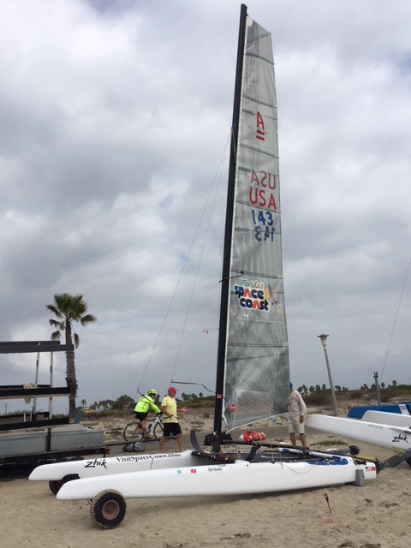Barracuda A-cat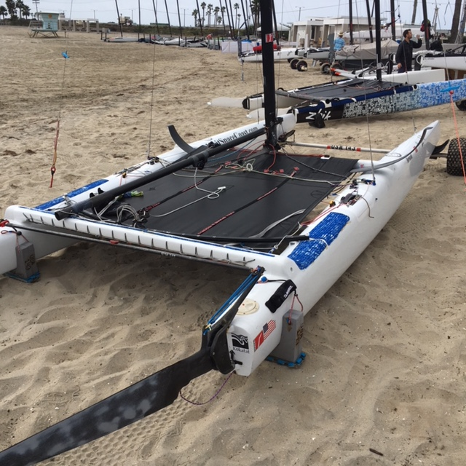

Hall Spars Barracuda, Can be sailed as Classic or Foiling, Comes with carbon DNA/J-Foils, carbon eXploder deep rudders w T-foils & castings, hulls autoclave cured prepreg carbon Nomex honey comb core finished w gloss white Awlgrip, beams autoclave cured High modulus prepreg carbon, custom Kinder trampoline, Hall medium flexi carbon mast, black matt Awlgrip finish (so you don’t need a cover), titanium mast rotation base, and 16:1 internal down haul. Carbon spreaders with adjustable tension, mast rotation arm, goose neck &(carbon) boom sheeting internal 12:1. Rigging 2.5 MM Dyform diamonds, NEW Dyneema light weight head stays, Mafioli main sheet & control lines, Glaser String sail main w fiber form battens. Comes w/ mid-mast wind vain, Wide knobby Dolly wheels & Kinder (TOP GUN) trailerable hull covers/very durable. Covers for all foils. Boat in excellent shape. ***Platform as stiff as any NEW boat on market now.

Mark Herendeen 321-863-4426

IF YOU BUY AND TAKE RECEIPT OF THE BOAT AT THE A-CAT North Americans in Sandy Hook its yours to race. And I will set it up for you.

Also, if we can agree on your interest and talk this week, I would consider coming a little off on price for a Sandy Hook club buyer. 321-863-4426

